Espoo Bricks

Table of Contents
Espoo M0002 Brick 3
Module overview 3
Hardware 3
Pinout 3
Circuit diagram 4
Programming Espoo M0002 with Arduino 5
Led blinking 5
Switch operation 6
DS18B20 temperature read 6
WiFi Acces Point 6

Espoo M0002 Brick

Module overview
Espoo M0002 Brick is an electronic WiFi module designed to operate the DS18B20 sensor. The module was built based on the ESP8266 chipset.
The module features:
- WiFi interface
- programming interface
- connector for DS18B20 sensor
- universal button
- programmable LED
- power indicator LED
The module can be programmed using the Arduino environment.

Hardware

Pinout
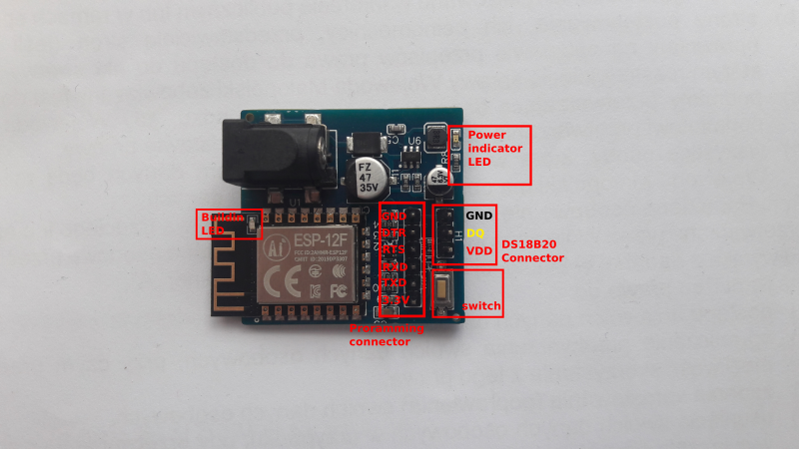
- DS18B20 DQ is connected to GPIO4 pin
- switch is connected to GPIO0 pin
- buildin LED is connected to GPIO2 pin

Circuit diagram
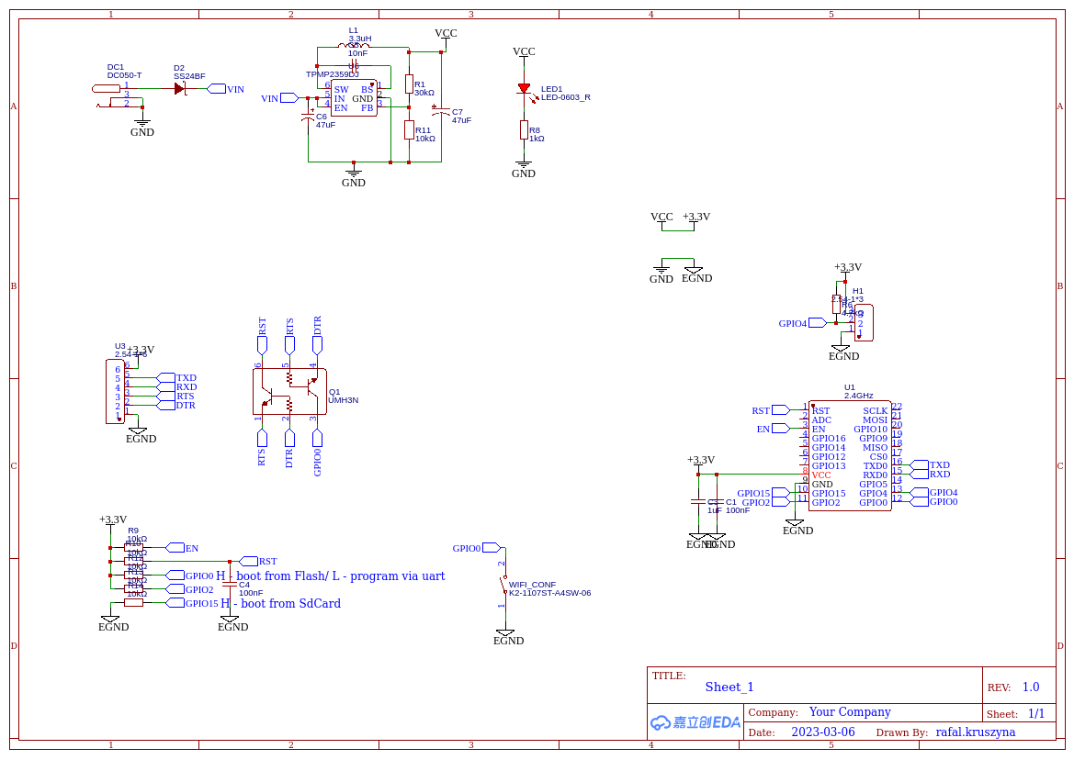

Programming Espoo M0002 Brick with Arduino

Led blinking
Sample arduino program for Espoo M0002 module blinking the built-in LED. The LED is connected to GPIO2 pin.

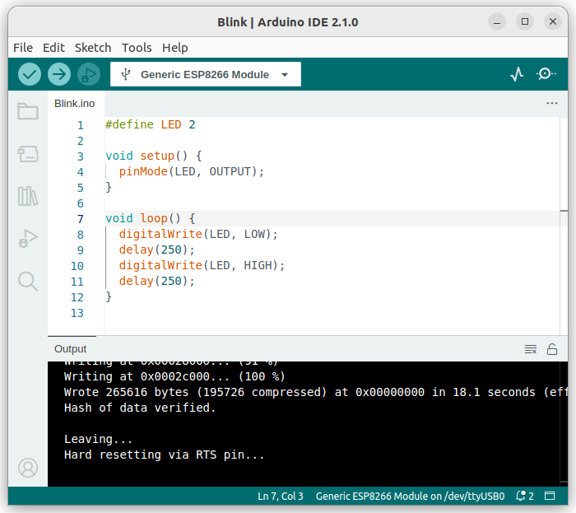

Switch operation
Sample Arduino program for Espoo M0002 module, illuminating the built-in LED when the button is pressed. The button is connected to GPIO0 pin, and the LED is connected to GPIO2 pin.

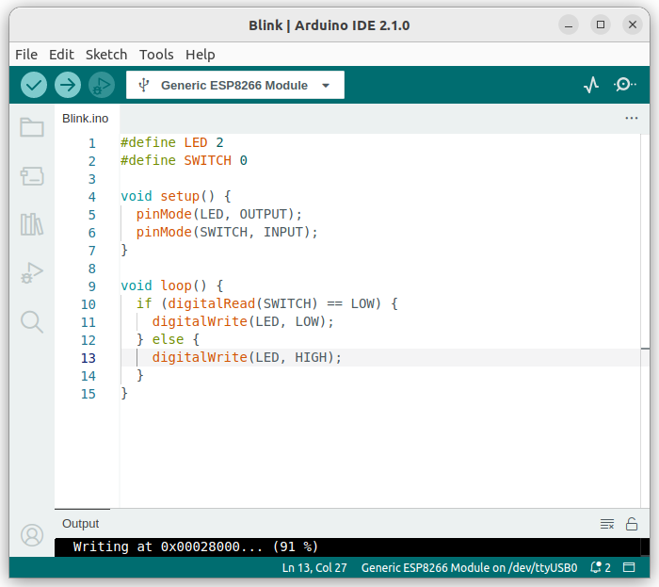

DS18B20 temperature read

WiFi Acces Point

